**Business Plan: The Saya Resort and Spa**

[Management Projects CW1]

MIB1 HM2

HM601



161 Spring Semester

Teacher: Mr. Patrick Taffin d’Heursel

Team Member: Myriam von Niederhäusern, 734413;

Yumie Jiang, 732908;

Aaron Cheng, 733010;

Lindsay Zhao, 734175;

Snow Ma, 734093;

Gin ,Li 734164;

Word count : 4851

6 May, 2016

Acknowledgments

The team would like to thank Mr. Taffin d'Heursel for his guidance during the process.

We also thank Christine Soraci for proofreading the work.

Then the authors thank Christa Buehlmann, Product Manager at tourasia Switzerland and the contacted Chinese travel agencies for providing valuable insights of booking patterns in choosing the destination Philippines.

The authors also thank Yu Sunyoung for providing valuable information about the Korean market.

Table of Contents

Acknowledgments II

Table of Contents III

List of Figures V

List of Tables VII

List of Abbreviations VII

1 Executive Summary 8

2 The Philippines – At a glance 11

3 Market Research 17

3.1 Global Trends in the Tourism Industry 17

3.2 Market area characteristics Philippines 18

3.2.1 International visitor arrivals 18

3.2.2 Top spending markets 19

3.2.3 Top source markets 19

3.2.4 Growth outlook on a National level 20

3.2.5 Korean Customers 21

3.2.6 Interviews with travel agencies 22

3.2.7 National Tourism Development Plan 2011 – 2016 23

3.3 Market area characteristics Palawan 26

Tourist Arrivals Palawan 26

3.3.1 Tourist Accommodation Capacity 27

3.3.2 Opportunities for Investment 28

3.4 Summary Market Research 29

3.5 Project site & area evaluation 30

3.5.1 Palawan 30

3.5.2 Ways to travel to Palawan 30

3.5.3 Restaurants and bars 33

3.5.4 Leisure activities 34

3.6 Competitive analysis 38

4 Concept development - Saya Resort and Spa 41

4.1 Core product 41

4.2 Actual product 42

Activities 51

4.3 Augmented product 56

4.4 Customer interaction with the service delivery system 58

4.4.1 Consumption phase 58

4.5 Benefits 59

5 Strategic direction 62

5.1 Vision statement 62

5.2 Positioning statement 62

5.3 Target market 63

5.4 SWOT analysis 65

Bibliography 67

Appendix A 72

Appendix B 73

Appendix C 75

Appendix D 76

Appendix E 77

Appendix F 79

Appendix G 80

List of Figures

Fig. 1: Saya Resort and Spa Location 9

Fig. 2: Photo from El Nido 10

Fig. 3: Market Research in Different in Philippines 10

Fig. 4: SWOT Analysis Philippines 2013 / 2014. 17

Fig. 5: Global Tourism Trends. 18

Fig. 6: International visitor arrivals. 19

Fig. 7: Top spending markets. 20

Fig. 8: Top source markets for 2015. 21

Fig. 9: Growth outlook for 2016. 21

Fig. 10: World cloud reasons to travel to the Philippines. 22

Fig. 11: Tourism Development Areas. 26

Fig. 12: Province of Palawan. 27

Fig. 13: Tourist Arrivals to Palawan, 2010-2014. 28

Fig. 14: Tourist arrivals in Palawan 2014. 29

Fig. 15: Tourism structure for 2014. 29

Fig. 16: Accommodation Capacity by Level of Service 2014. 30

Fig. 17: Strategies with potential. 30

Fig. 18: Market Research Summary. 31

Fig. 19: Ways to travel to El Nido. 32

Fig. 20:Transportation to El Nido. 33

Fig. 21: Timetable of flights between Manila and El Nido. 34

Fig. 22: Top 10 restaurants El Nido 35

Fig. 23: Food type. 35

Fig. 24: Restaurants near Saya Resort 36

Fig. 25: Tours in El Nido. 37

Fig. 26: Map of El Nido island-hopping tours. 37

Fig. 27: The distance from our resort to midtown. 38

Fig. 28: Surroundings of our resort. 39

Fig. 29: Map of the resort. 44

Fig. 30: Dagat- forest room. 45

Fig. 31: Dagat-double room. 46

Fig. 32: Gubat room. 46

Fig. 33: Baybayin villa 47

Fig. 34: Nest - with mobile Spa services 48

Fig. 35: Indigo Perlas Spa. 49

Fig. 36: Indigo Perlas Spa. 49

Fig. 37: Masaya Restaurant. 50

Fig. 38: Lakas restaurant. 51

Fig. 39: Activities. 55

Fig. 40: Private Movie Night (1)(Swim Pool) 55

Fig. 41: Private movie nights. 55

Fig. 42: Horseback Riding 55

Fig. 43: Ping-pong in Water 55

Fig. 44: Beach Yoga (Class) 56

Fig. 45: Beach Bowling/water bottle bowling 56

Fig. 46: Beach Volleyball 56

Fig. 47: Beach BBQ 56

Fig. 48: Waterfall Jumping – Resort will be built close to a waterfall 57

Fig. 49: Staffs welcome performance. 59

Fig. 50:Welcome Drink. Mango Shake. 59

Fig. 51: Characteristic Reception Design 60

Fig. 52: Banana Chips 60

Fig. 53: Room service massage 61

Fig. 54: Porter’s Generic strategies. 65

Fig. 55: Framework for Sport- Eco-tourists. 67

Fig. 56: SWOT Analysis. 69

List of Tables

Table 1: Types of rooms 10

Table 2: Philippines’ General Information 12

Table 3: Key data about Philippines’ Economic. 14

Table 4: Key data about Philippines’ Environment. 15

Table 5: Key data about Philippines’ Political. 16

Table 6: Comparison cost of living. 22

Table 7: Interview. 23

Table 8: Interview. 39

Table 9: Interview. 44

Table 10: Benefits 60

Table 11: Overview over the different generations. 64

List of Abbreviations

TDA Tourism Development Areas

VPY Visit the Phillippines Year

DOT Department of Tourism Philippines

APPI Asia Pacific Projects, Inc.

1. Executive Summary

This report presents the elaborated concept for **Saya Resort and Spa** located in the Philippines, El Nido (the specific location is 11°18'00. 1"N 119°25'04. 2"E).

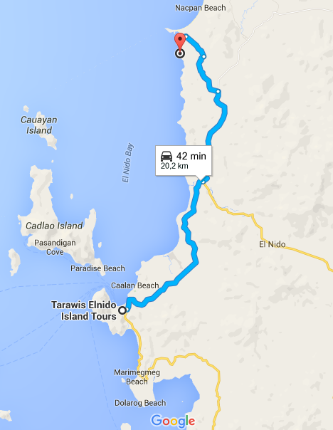

Fig. 1: Saya Resort and Spa Location

Source: 11°18’00.0"N 119°25’00.0"E, no date

The Philippines is the third largest English Speaking Country in the world and consists of up to 7,107 islands. It combines Asian, European and American influences.

Palawan where Saya Resort and Spa is located is also called the “Last Frontier” of Philippine being a paradise for its misty mountains, beautiful and untouched islands, teeming and various wildlife, and less commercial beaches.



Fig. 2: Photo from El Nido

Source: Resorts, 2016

The conducted market research showed the following findings:

Fig. 3: Market Research in Different in Philippines

Responding to the identified trends Saya Resort and Spa is a mid-tier service Eco-resort which is in line with the eco-tourism theme of Palawan.

**Saya Resort and Spa’s concept is: tranquil but active holiday, away from crowded places in a secluded environment**

Saya Resort and Spa offers 4 different types of rooms which provide either a beautiful ocean view or forest view.

Table 1: Types of rooms

Total room number : 60

Categories: 4

**Dagat** room (**dagat means seaview**) 20

Dagat doble room (seaview) 20

**Gubat** room (**gubat means forest view)** 10

Baybayin vila (**Baybayin means shore**) 10

It offers a wide range leisure activities and Spa treatments.

Saya Resort and Spa invests in the future of young people by giving them the opportunity to work for it (which in turn helps decrease the high unemployment rate of young people (16.2%) in the Philippines).

Saya Resort and Spa also offers child care and will have a school for the children of the employees. It hopes to attain high employee satisfaction, which will then be reflected in the excellent customer service provided.

According to these core values the vision is the following:

**In Touch With Nature, Preserving Its Beauty In A Sustainable Way, Equality And Nurture Are The Keys To Growth And Financial Stability.**

Saya Resort and Spa targets the following target markets:

Travellers wanting to discover untouched and secluded places

Sport and nature fans wanting a touch of luxury while looking for adventure

**Travellers wanting to unwind**

Local people wanting to profit from our Spa facilities

Addressing the target market it’s positioning statement is the following:

Ultimate relaxation and sport experience in a breath-taking secluded location. Saya Resort and Spa offers sport and nature fans a variety of leisure activities. Travellers wanting to unwind profit from private forest rooms and natural based spa treatments.

1. The Philippines – At a glance

The Philippines is the third largest English speaking country in the world and consists of up to 7,107 islands. It combines Asian, European and American influences. The Department of Tourism describes its people as freedom and fun-loving people. (The Department of Tourism Manila Philippines, 2009)

The following tables explain some of the key facts about the country to provide an overview about some key indicators which will affect the planning of the project.

Table 2: Philippines’ General Information



Table 3: Key data about Philippines’ Economic.

Source: CIA, 2016b.





Table 4: Key data about Philippines’ Environment.

Source: CIA, 2016b.



Table 5: Key data about Philippines’ Political.

Source: CIA, 2016b

To sum up this chapter the SWOT analysis conducted by the Trade Section of the Swiss Embassy in Manila is presented. The presented data help to understand the environment in which the resort will be build in.

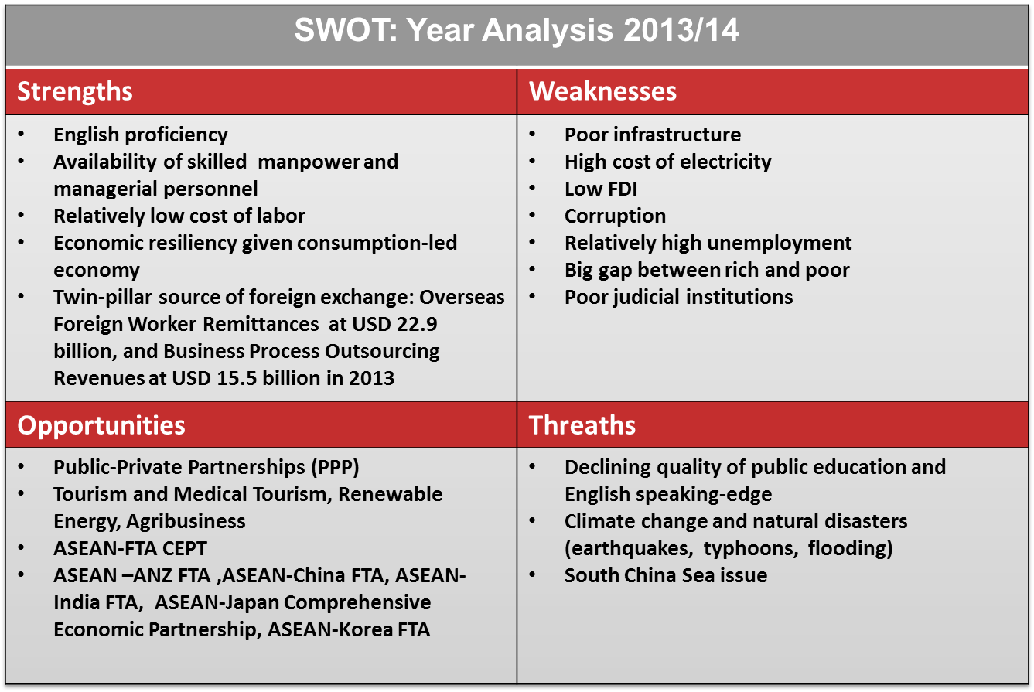

Fig. 4: SWOT Analysis Philippines 2013 / 2014.

Source: Trade Section Embassy of Switzerland, 2014.

1. Market Research

This chapter will present the findings of the conducted Market Research.

* 1. Global Trends in the Tourism Industry

According to Lucy Fuggle (2016) from Trekk Soft - an online booking software and website builder used by tour operators and activity providers - the following trends will affect the tourism in 2016:



Fig. 5: Global Tourism Trends.

Source: Fuggle, 2016.

Fuggle (2016) explains that there is a rising trend of tourist wanting to unplug and sign-off completely form work on holiday. At the same time Wi-Fi remains a key requirement. However, some remote hotels are using the lack of Wi-Fi as selling point to completely sing-off.

Fuggle (2016) also predicts an increase in international business travel and a greater flexibility for travel during career breaks.

According to Fuggle (2016) about 20 % of the world’s tourists are young travellers who seek unique and authentic experiences and opportunities. The trend of having a holiday closer to home is predicted to continue for 2016. (Fuggle, 2016).

* 1. Market area characteristics Philippines

Tourism has become one of the major economic drivers in the Philippines, even though it has experienced challenges like typhoons and earthquakes. (Official Gazette of the Republic of the Philippines 2016)

In Appendix A there are some reasons listed which could have contributed to the considerable growth.

The following subchapters will give an overview over some key figures of the Tourism Industry in the Philippines.

* + 1. International visitor arrivals

Looking at the development during the past years a steady growth can be noticed (see Fig 6). 2015 was the first year where inbound tourists surpassed the five million mark with 5,360,682 visitors. (Official Gazette of the Republic of the Philippines 2016)

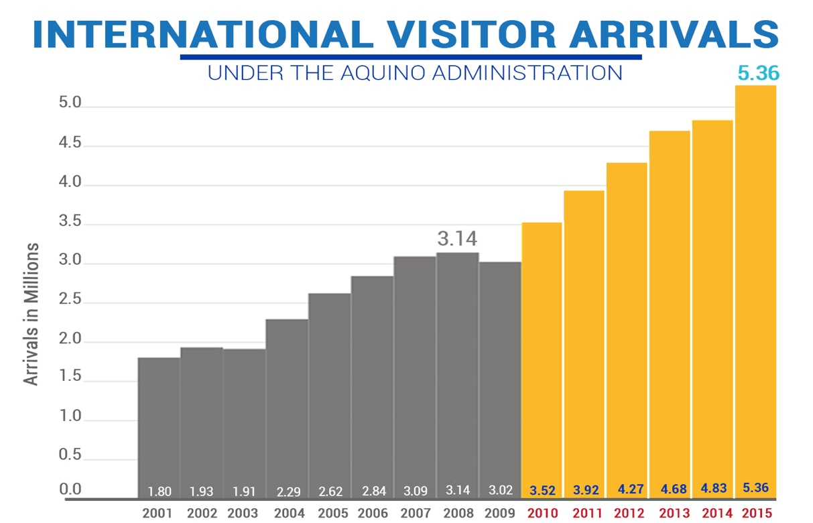

Fig. 6: International visitor arrivals.

Source: Official Gazette of the Republic of the Philippines 2016.

* + 1. Top spending markets

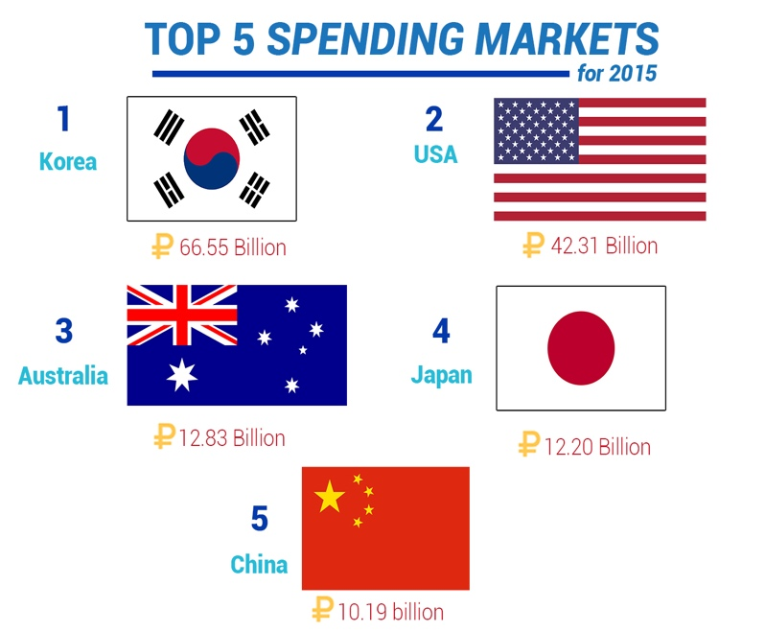Examining the top spending markets in 2015 (see Fig. 7) it shows that Korea is at the very top with P66.55 billion spent followed by the United States and Australia.

Korea was also the biggest source market with 1.34 million visitors which reflects about 25% of total arrivals. It was also the first country to surpass 1.3 million visitors. Since 2012 has remained consistent with more than 1 million arrivals per year. (Official Gazette of the Republic of the Philippines 2016)

Fig. 7: Top spending markets.

Source: Official Gazette of the Republic of the Philippines 2016.

* + 1. Top source markets

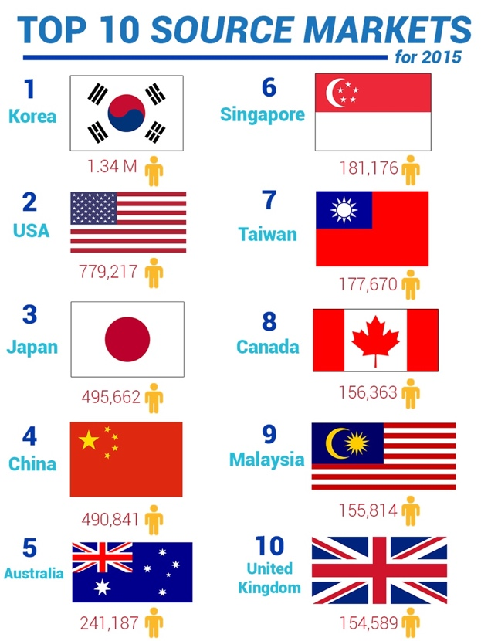As aforementioned the Korean market was the top source market, followed by the USA and Japan (see Fig. 8). (Official Gazette of the Republic of the Philippines 2016)

Fig. 8: Top source markets for 2015.

Source: Official Gazette of the Republic of the Philippines, 2016.

* + 1. Growth outlook on a National level

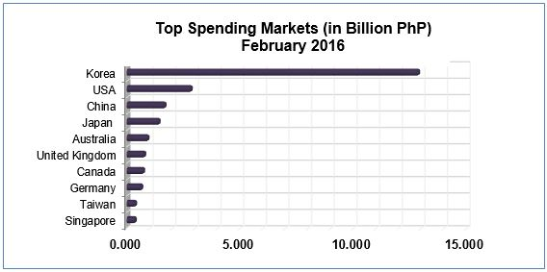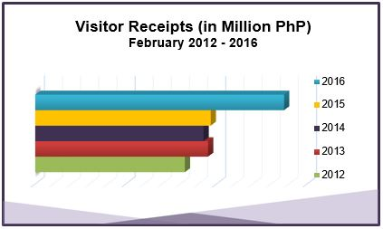In February the trend of growth continued with 549,725 visitors arriving (in 2014 the number of arrivals was 456,524 this reflects a growth of 20.42 %). (Department of Tourism 2016)

Fig. 9: Growth outlook for 2016.

Source: Department of Tourism, 2016.

According to the Department of Tourism countries with substantial growth other than the top source markets are France with 12,502 (+22.10%), Spain with 5,092 arrivals (+32.23%), Sweden with 7,073 arrivals (+21.09%), Indonesia with 8,824 arrivals (+16.66%), Switzerland with 6,494 arrivals (+17.09%), Netherlands with 6,049 arrivals (+13.83%), and New Zealand with 3,294 arrivals (+13.55%)(Department of Tourism, 2016).

* + 1. Korean Customers

According to an interview, Philippine Ambassador to Korea Luis Cruz gave in 2013 he said the following factors are attracting Koreans to come to the Philippines.

Fig. 10: World cloud reasons to travel to the Philippines.

Source: Own graph by authors, 2016.

A close South Korean friend (Yu Sunyoung ) of one of the group members confirmed this. Korean people are attracted by the lower costs of living and seek the opportunity to learn English (see tables 6).

According to the immigration office of the Philippines it issued 30,000 study permits (English language studies or other study subjects) out of which 27,000 were issued to Korean students (Philippines–South Korea relations, 2016)

.

For adults approaching retirement age it seems appealing to live in the Philippines because here they can afford some employees like housekeepers (according to Yu Sunyoung). This subjective statement is confirmed by the strategy of the Philippines to attract people to retire in the Philippines. The Filipino retirement authority advertises itself as “Smile at Life in the Philippines” and that people could expect a good life there at an affordable cost (Philippine Retirement Authority, 2007).

Table 6: Comparison cost of living.

source: The Economist, 2016; CIA, 2016a.



But there has also been some negative news about Koreans who were killed in the Philippines. In November 2015, the ministry of South Korea imposed a travel ban on some areas of the Philippines (Asian Times, 2015).

* + 1. Interviews with travel agencies

The authors contacted some travel agencies in China and Switzerland to source some trends in the European (growing market according to market research) and Chinese market (one of top soure market).

Table 7: Interview.

source: E-Mail from tourasia 29 April 2016; Appendix B



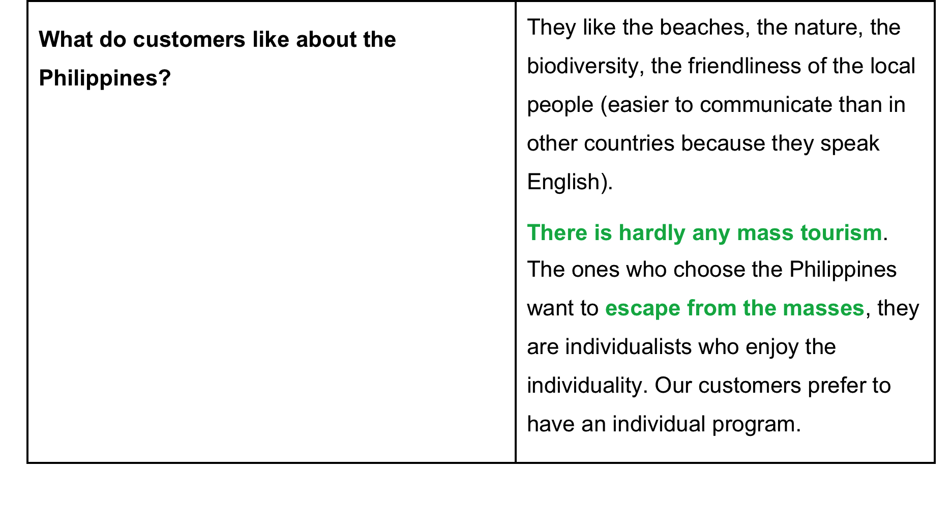



* + 1. National Tourism Development Plan 2011 – 2016

According to the National Tourism Development Plan 25 tourism destination clusters covering 77 Tourism Development Areas (TDAs) were identified:



Fig. 11: Tourism Development Areas.

Source: Lim, 2015.

Condé Nast Travelerreaders voted Philippines’s Palawan Island the Number 1 Island in the World. (Conde Nast Traveler, 2016)

The provincial government is therefore trying to increase the number of tourists. (Interaksyon, 2015).

The project group also decided to build the Resort in the Province Palawan. Chapter 3.5 area evaluation will explain a more in-dept reasoning behind the choice.

The province of Palawan is a Tourism Cluster of four TDA’s (see Fig. 12)



Fig. 12: Province of Palawan.

source: Lim, 2015.

* 1. Market area characteristics Palawan

This subchapter will introduce the market characteristics of Palawan. Appendix C presents some key data of Palawan as well as the strategy of the Government to develop the region.

Tourist Arrivals Palawan

Fig. 13 shows the development of tourist arrivals in Palawan:



Fig. 13: Tourist Arrivals to Palawan, 2010-2014.

source: Lim, 2015.

Similarly to the national level a steady increase in tourist arrivals can also be witnessed in Palawan. We highlight the fact that more domestic than foreign guests arrived in Palawan.

In 2014 the majority of tourists (78.9%) stayed in Puerto Princesa (see Fig. 14).

All TDAs except for the Northern Palawan have a strong domestic market

* + 1. Tourist Accommodation Capacity

In 2014 the Province of Palawan has 566 tourist accommodation establishments offering about 7,500 rooms:

Fig. 14: Tourist arrivals in Palawan 2014.

Source: Lim, 2015.



Fig. 15: Tourism structure for 2014.

Source: Lim, 2015.



Fig. 16: Accommodation Capacity by Level of Service 2014.

Source: Lim, 2015.

According to the expert advice of Narzalina Z. Lim (2015) President, Asia Pacific Projects, Inc. (APPI) there is room for expansion for mid- and top-tier accommodation facilities in all TDAs.

* + 1. Opportunities for Investment

According to Lim (2015) the following strategies were identified for Palawan:



Fig. 17: Strategies with potential.

Source: Lim, 2015.

As strategy Eco-tourism themed attractions are recommended with an investment in mid- to top-tier accommodations that would be in line with Palawan’s eco-tourism theme.

Investments in health and wellness spa-resort facilities are also recommended. (Lim, 2015)

* 1. Summary Market Research

The following chapter summarizes the key findings of the market research.

Fig. 18: Market Research Summary.

Appendix D summarizes the key facts 2015 about the top source markets (including a growth outlook based on the first months in 2016).

Analyzing the data the authors decided on the following strategy:



* 1. Project site & area evaluation

This chapter will introduce Palawan and the chosen destination in more detail.

* + 1. Palawan

Palawan consists of three major areas, which include Puerto Princesa, El Nido and Coron. It is called the “Last Frontier” of Philippine being a paradise for its misty mountains, beautiful and untouched islands, teeming and various wildlife, and less commercial beaches (itsmorefuninthephilippines.com, 2016).

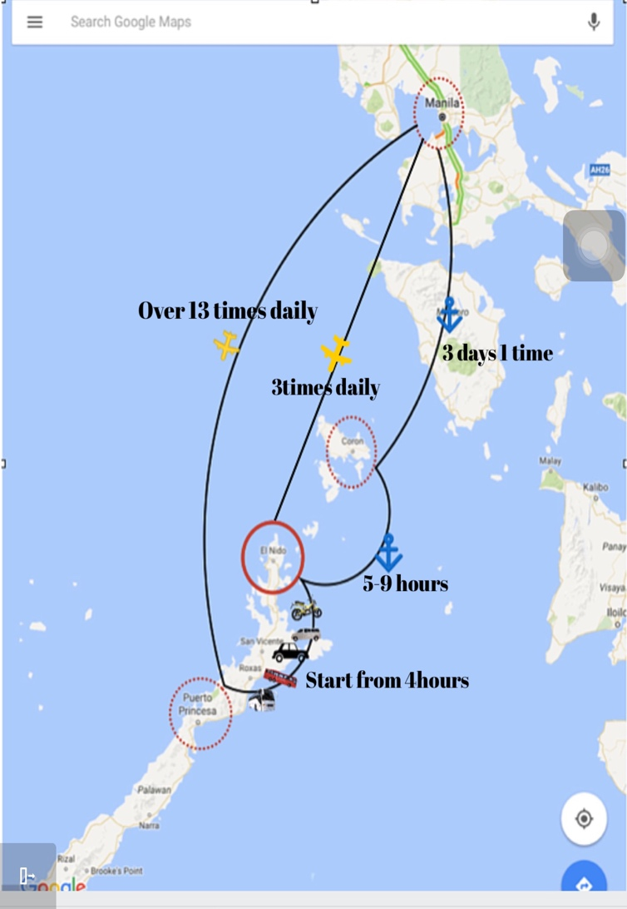As one of the three major destinations, El Nido is located in Northen Palawan, between Puerto Princesa and Coron. With the magnificent Bacuit Bay and scenic islands, El Nido attracted the producer to shoot the Hollywood film, Bourne Legacy, in 2012 (new. abs-cbn.com, 2012). This movie has increased the popularity of El Nido and has attracted more and more tourists to travel to El Nido (gopalawan.travel.com, 2016).

Fig. 19: Ways to travel to El Nido.

Source: Jiang, 2016.

* + 1. Ways to travel to Palawan

There are 3 major ways to travel to El Nido (see Fig. 19), which include flights, land and water transportations (see Fig 20).

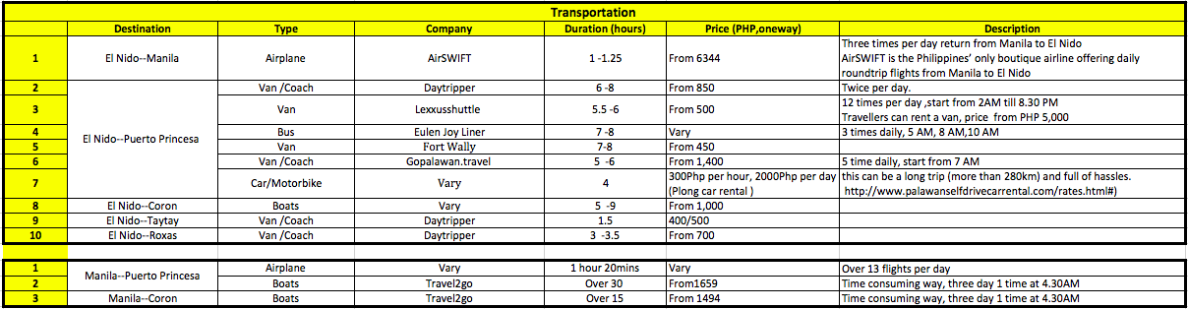

Fig. 20:Transportation to El Nido.

Source: air-swift.com; daytripperpalawan.com; travle.2go.com.ph; Lexxusshuttle.com; iloveelnido.com; Facebook.com/Fortwally-travel-and-tour; gopalawan.travel; palawan-divers.org; palawanselfdrivecarrental.com; caalanbeachresort.com, 2016.

.

There are 3 direct return daily flights, starting from php 6,344 offered by Air Swift Company from the capital city Manila to El Nido (air-swift.com, 2016) (see Fig 21), and only takes about 1 hour to arrive at the Lio airport, located around 4km from the town.

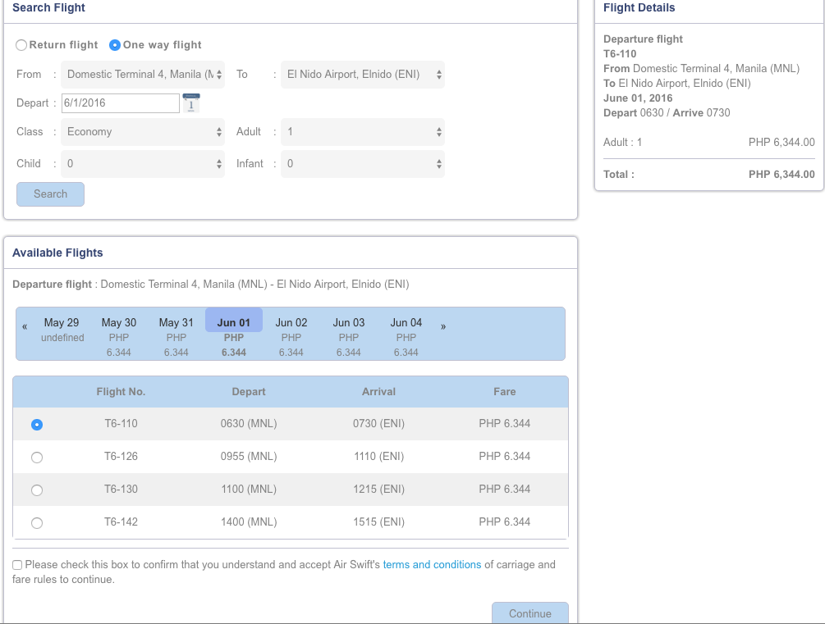

Fig. 21: Timetable of flights between Manila and El Nido.

Source: air-swift.com, 2016

This is the most expensive, most direct and fastest way to arrive in El Nido (Palawan-divers.org, 2016). The second way to arrive in El Nido is land travel from Puerto Princesa city, the biggest city of Palawan and around 220 km away from El Nido (Palawan-divers.org, 2016). There are more than 5 companies providing over 20 daily coaches or vans services between Puerto Princesa city and El Nido. It takes about 5 to 8 hours with various prices starting from php 450. In addition, travellers also can rent cars or motorbikes at different prices from local car rental companies. For example, Plong Car Rental Company provides car rental services at php 300 per hour (palawanselfdrivecarrental.com, 2016). It will take over 4 hours to drive from Puerto Princesa city to El Nido. Travellers can also get to El Nido from Coron by boats, etc.

* + 1. Restaurants and bars

For lower development level than other famous Islands, there are about 59 restaurants and bars in El Nido. Most of these shops are located in the midtown of El Nido, and the top 10 restaurants are major in Asian, Italian, Mediterranean and international food (see Fig 22 and Fig 23).

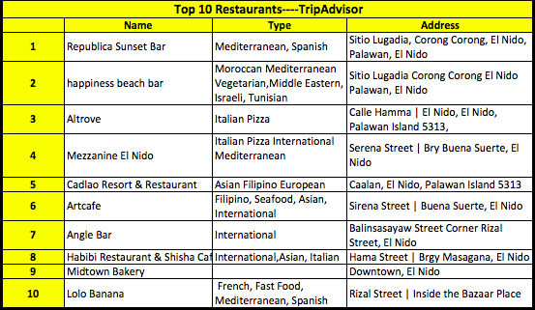

Fig. 22: Top 10 restaurants El Nido

Source: TripAdvisor, 2016.

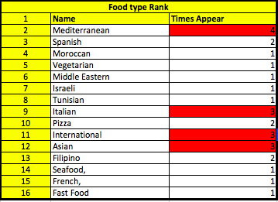

Fig. 23: Food type.

Source: Jiang, 2016.

Three of those restaurants are near our resort location, which get low comments from the users of Tripadvisor for they provide very low-level quality food and poor dining environment (tripadvisor.com, 2016).

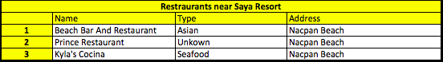

Fig. 24: Restaurants near Saya Resort

Source: TripAdvisor, 2016.

* + 1. Leisure activities

There are 45 islands with spectacular beaches and over 30 diving sites in El Nido (padi.com 2016). Benefits from those treasures, El Nido offers a wide range of outdoor activity options for travellers who are ocean and nature lovers. Over 30 activities can be found in this beautiful Island (Vito, 2015). You can choose from water and inland activities. Water activities include Kite boarding, Windsurfing, Scuba Diving, Snorkelling, Stand up paddleboard (elgordoadventures.com, 2016). Inland activities include Mountain biking, Cliff climbing (McGrain, 2015) and Zipline[1], etc. (Palawan-divers.org, 2016). There are also five PADI Dive Shops providing diving courses to those travellers who are interested in learning and practising diving (padi.com 2016). In addition, people also can find sailing courses from the local IYT[2] Sailing School in El Nido (Palawan-sailing.com, 2016).

The best way to discover those hidden beaches and have a great snorkelling day in the beautiful Bacuit bay is Island Hopping. It is one of the most popular activities in El Nido (Palawan-divers.org, 2016). Moreover, there are five sorts of day tours offered by local travel agencies (gopalawan.travel.com, 2016). Tour A, B, C, D and E which include the most popular islands and beaches in El Nido (from1to10.com, 2016)(see Fig 25 and Fig 7).

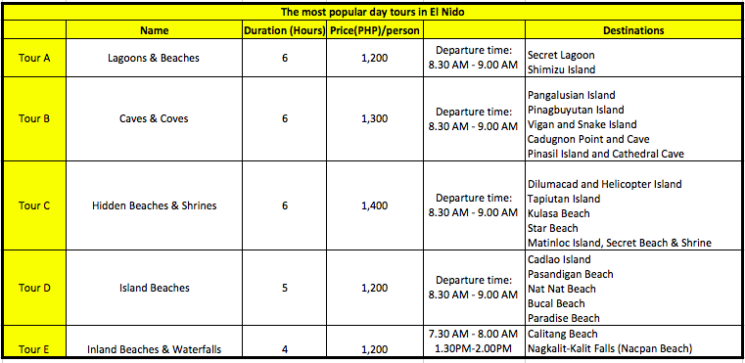

Fig. 25: Tours in El Nido.

Source: gopalawan.travel, 2016.

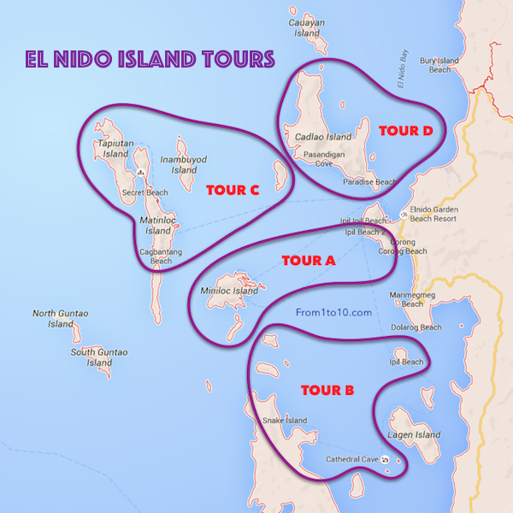

Fig. 26: Map of El Nido island-hopping tours.

Source: from1to10.com, 2016

In this project, we chose the place which is close to the Nacpan Beach and Bologs Islands. **The specific location is 11°18'00. 1"N 119°25'04. 2"E**，on Google map (google.com, 2016). It is around 20km away and 42mins driving from the midtown (see fig. 27)



Fig. 27: The distance from our resort to midtown.

Source: Google map, 2016.

This is a non-commercial area surrounded by nature, there are only three restaurants and one beach named Nacpan Beach (tripadvisor.com, 2016). “Where 2 next” is the only accommodation in this area, but it is a very low budget hostel. Beside this, there is nothing else in this area (see Fig 28). The very welcoming Nacpan beach and low direct competition, are the reasons why we chose this place to build our resort.

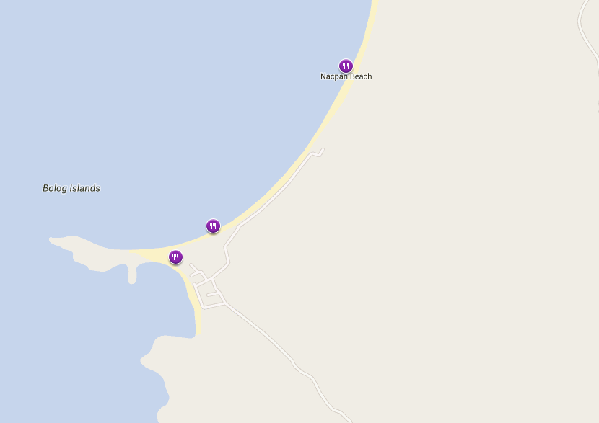

Fig. 28: Surroundings of our resort.

Source: tripadvisor.com, 2016

* 1. Competitive Analysis

This chapter will present the findings of the competitive analysis (see Table 8):

Table 8: Interview.

Source: Resorts, 2016

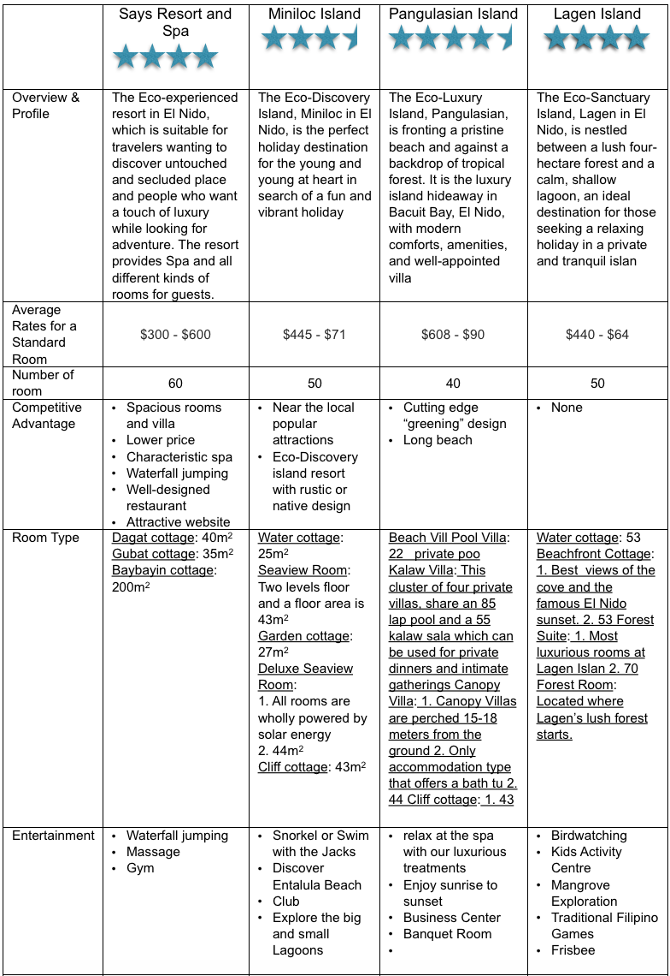

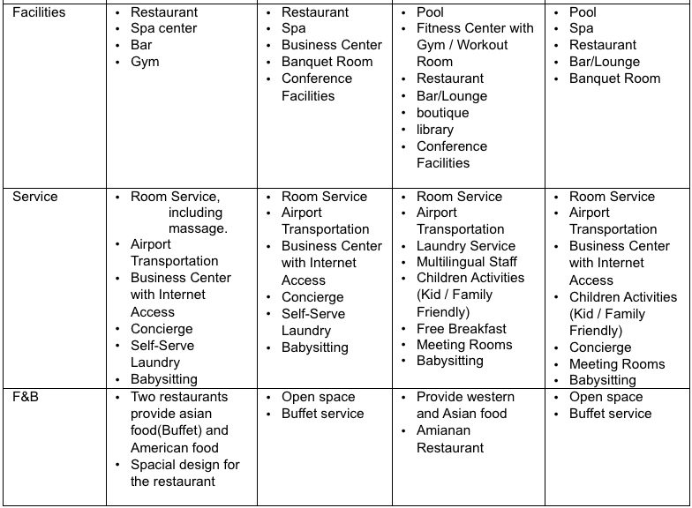

1. Concept development - Saya Resort and Spa

As described in chapter 3.2.5 Filipinos are fun-loving people and therefore, the authors chose to name the Resort in a Filipino name which means fun (saya). The concept of using Filipino names is kept and the other facilities will also be named in Filipino. This chapter presents the concept development.

* 1. Core product

**Saya Resort and Spa’s** concept is: tranquil but active holiday, away from crowded places in a secluded environment

* 1. 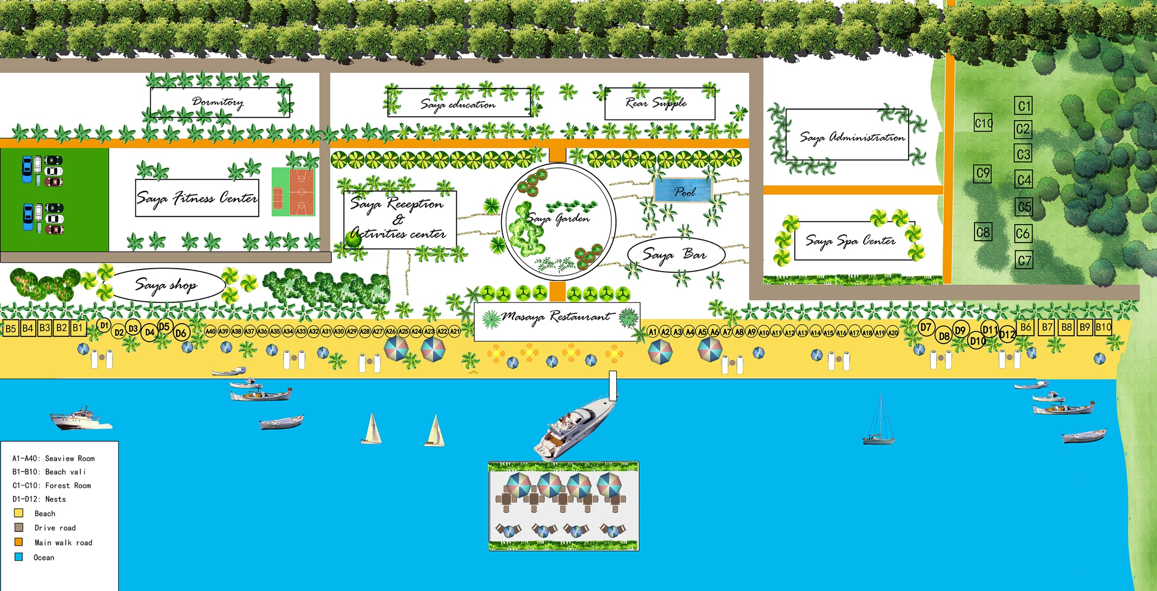Actual product

Fig. 29: Map of the resort.

Source: Ma, 2016.

**ROOMS:** Saya Resort and Spa offers 4 different types of rooms (see following picture) , which provide either a beautiful ocean view or forest view.

Table 9: Interview.

Total room number : 60

Categories: 4

**Dagat** room (**dagat means seaview**) 20

Dagat doble room (seaview) 20

**Gubat** room (**gubat means forest view)** 10

Baybayin vila (**Baybayin means shore**) 10

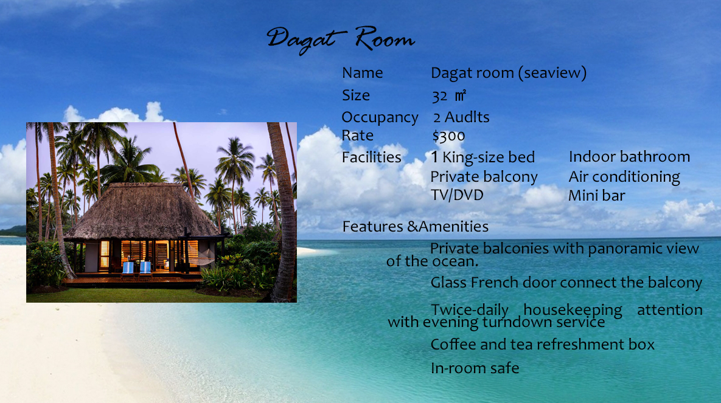

Fig. 30: Dagat- forest room.

Source: Ma, 2016.

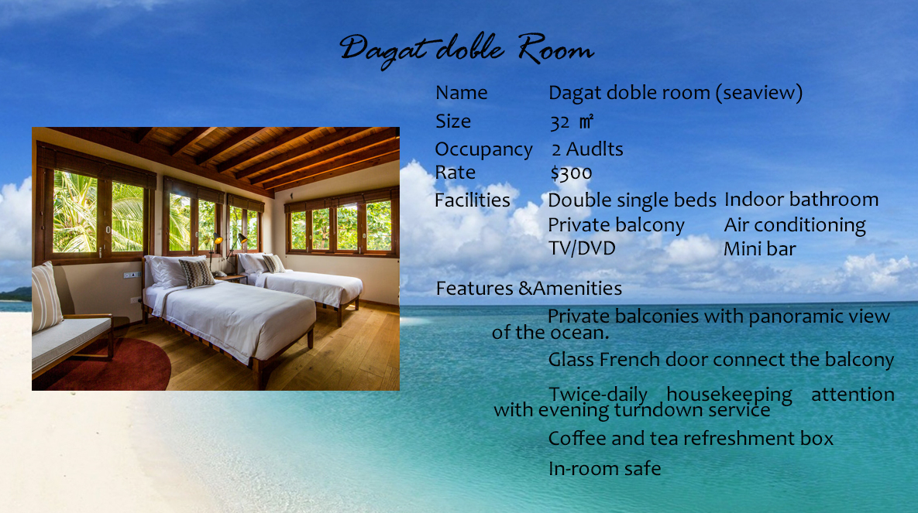

Fig. 31: Dagat-double room.

Source: Ma, 2016.

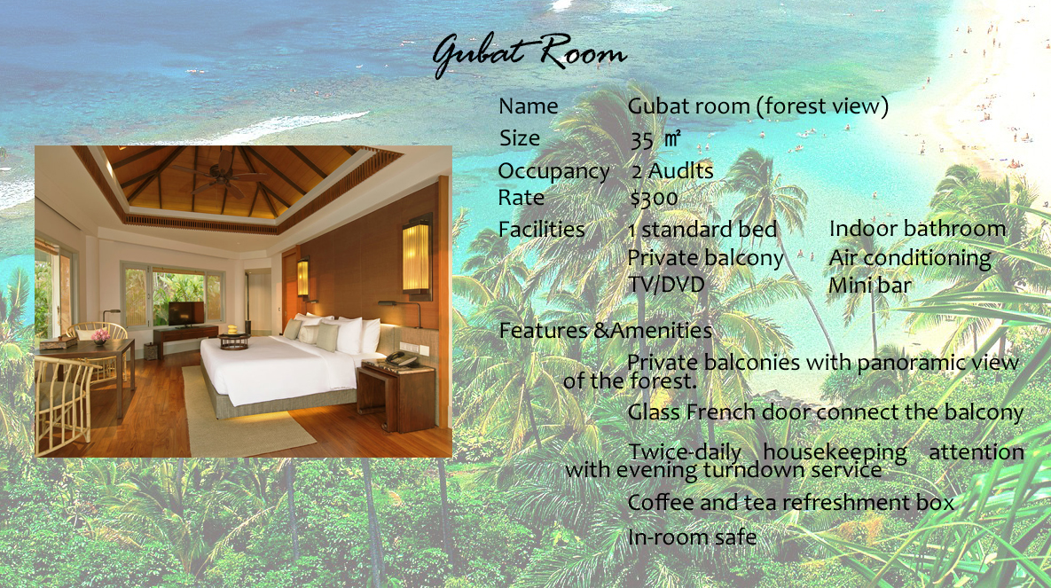

Fig. 32: Gubat room.

Source: Ma, 2016.

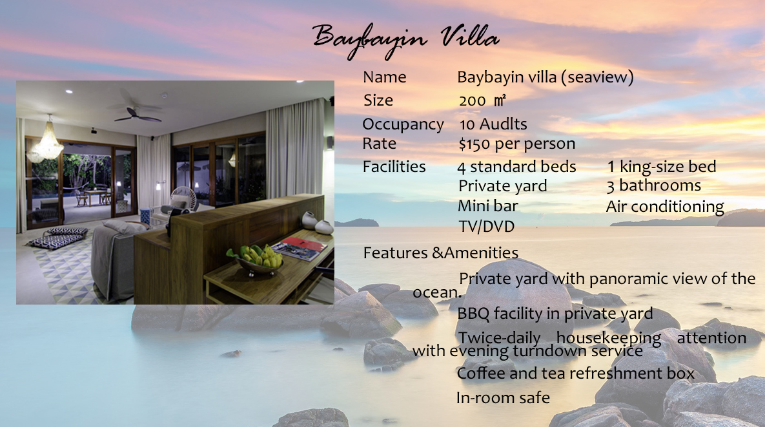

Fig. 33: Baybayin villa

Source: Ma, 2016.

**SPAS:** Saya Resort and Spa has 2 types of spa, one is luxurious, called nest spa, guests can relax in the special tree nest buildings, and also can use mobile service to call spa and massage here. And the inside Indigo perlas spa (pearl in Filipino) provides a traditional and natural spa.

**Nest spa**

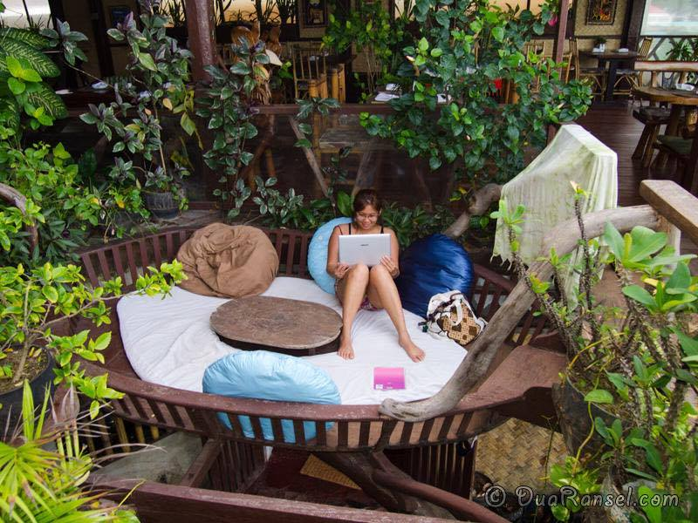

Fig. 34: Nest - with mobile Spa services

Source: Dua Ransel, 2013.

**Indigo perlas Spa**

The newly designed Spa is a source of energy for the body, mind and soul. A special place in the north of Palawan, where we will combine knowledge of nature with trend and tradition.

It is a specialized spa center near the beach, which features the Semi-Open layout rather than totally enclosed style. This design will help customers to be at one with nature.

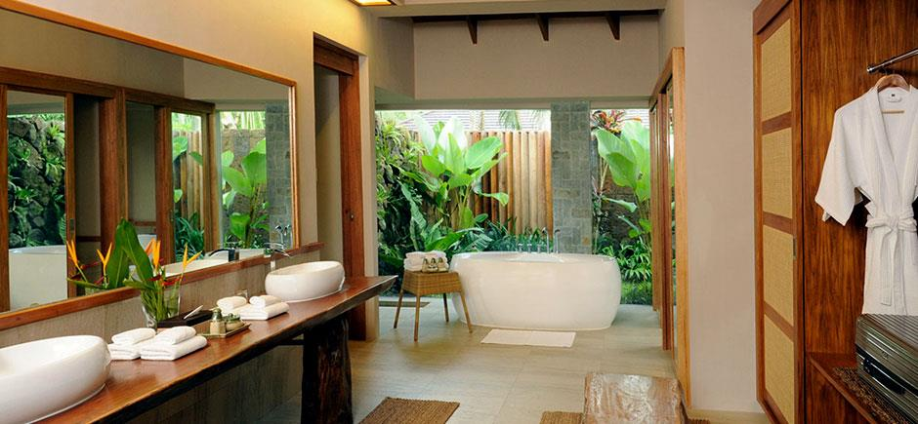As well as a large Roman pool, there will be two different types of semi-open private treatment rooms which are tailor-made for relaxing. In general, there will be four treatment rooms for single person and 3 rooms for double or couples. Customers can make the reservation for the room of their preference first and schedule their own treatments.

Fig. 35: Indigo Perlas Spa.

Source: Lim, 2015.

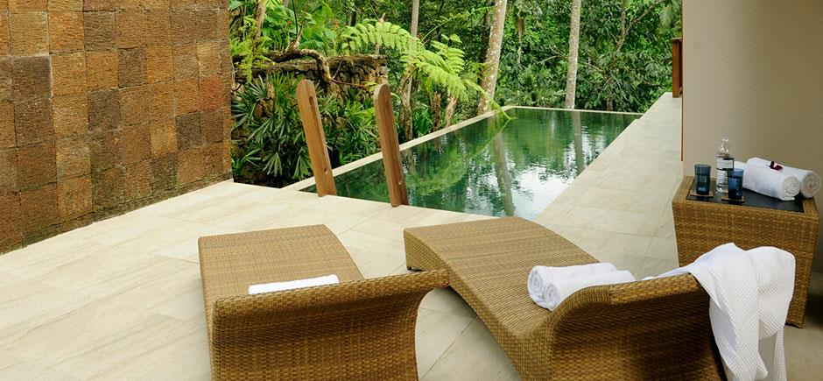

Fig. 36: Indigo Perlas Spa.

Source: Lim, 2015.

The Indigo perlas spa is one of the leading attractions in our resort (according to the market research spa facilities are recommended) and is also a specialty characteristic which enables to attract more tourists who are not only wanting to escape from the bustling city life but also are interested in a spa regimen for a relaxed and tranquil vacation. Since the aim of the resort is to focus on the concept of eco-friendly, it is undisputed that the main theme of our spa is to have everything in harmony with nature, namely [additive](C:/Users/Administrator/AppData/Local/Yodao/DeskDict/frame/20160227050726/javascript:void(0);) [free](javascript:void(0);).

The spa menu can be found in Appendix E.

**Restaurants:**

We have 2 restaurants, one is the Asian restaurant which is on the beach, and the other offers American food (USA as top source market, apart from International restaurant in El Nido no specific American restaurant found in the area), and is built on the ocean. When the occupancy is 100%, the amount of guests should be 200, we use 80% occupancy to calculate restaurants' covers, the total cover should be 160.

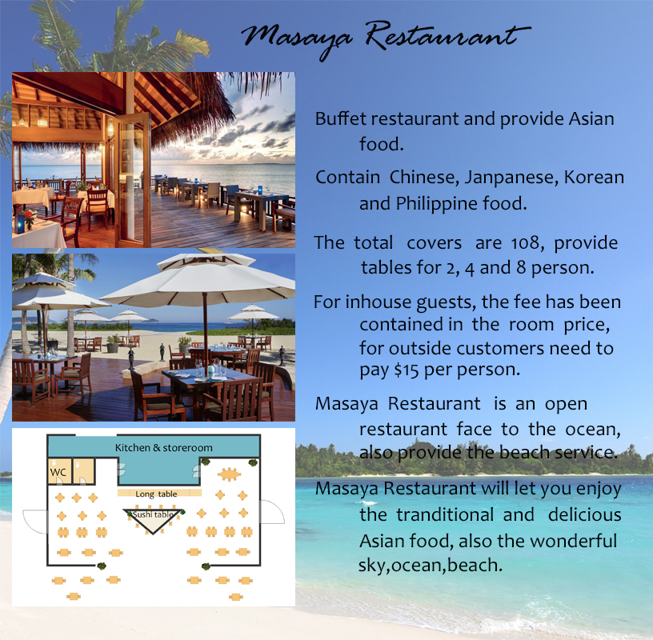

Fig. 37: Masaya Restaurant.

Source: Ma, 2016.

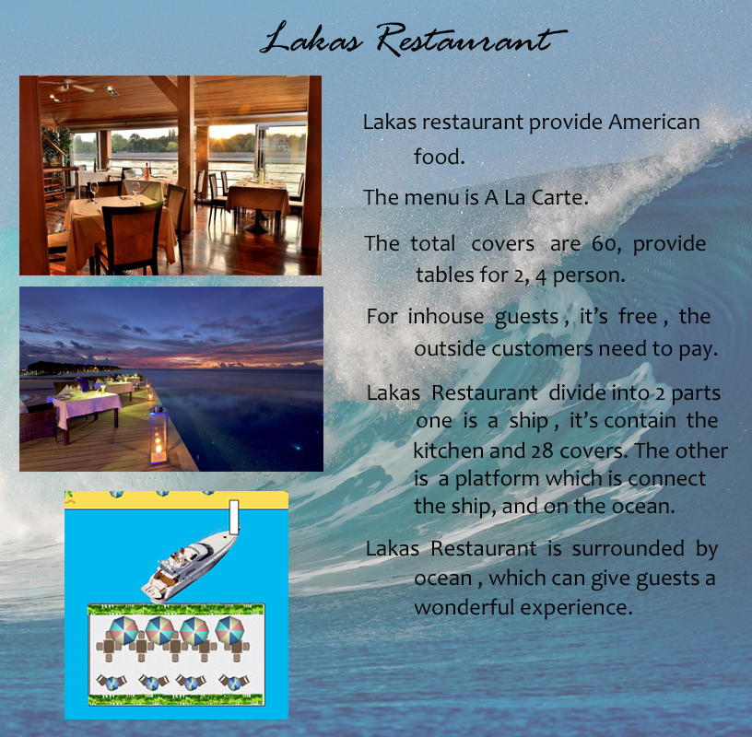

Fig. 38: Lakas restaurant.

Source: Ma, 2016.

**Reception and Activities Centre:** Our resort’s reception and activities centre both in one building are designed to let guests check in and organize activities.

**Silim – Twilight bar:** we have one small bar which is near the beach.

**Sports**: we have one fitness centre which is near the beach, and also one outdoor volleyball court and pool.

**Other buildings**: we have one shop, one administration building, one rear supply building which contains the laundry room and storage room

**Saya Education**: We invest in the future of our young people by giving them the opportunity to work for us (which in turn helps decrease the high unemployment rate of young people (16.2%) in the Philippines). Saya Resort and Spa also offers child care and will have a school for the children of the employees (because in the Philippines there are many young mothers, the average age of having the first child is 23). We hope to attain high employee satisfaction, which will then be reflected in the excellent customer service provided.

Activities

The following table shows the activities we would like to offer. In addition to the in-house activities (see Fig 39) we will also offer tours taking the guest to different islands (see Fig 25).

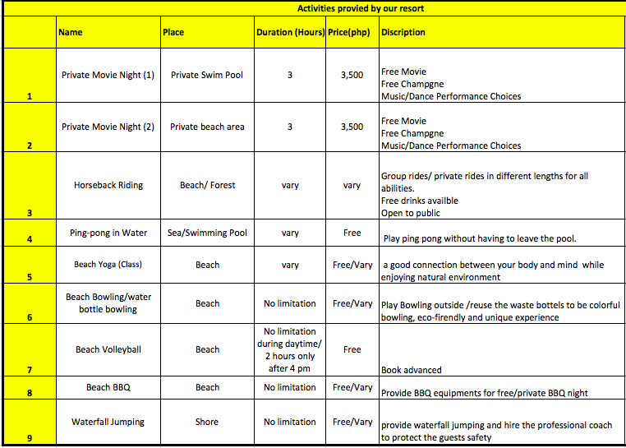

Fig. 39: Activities.

Source: fourseasons.com/orlando, Elegance Paradise, halfmoon.rockresorts.com , gibsan.wordpress.com , traveltherapytours.com, androidtapp.com/ craftsbyamanda.com, lfsmexpo.com, uk.pinterest.com, guidetoboracay.com, 2016.

|  |  |  |  |
| --- | --- | --- | --- |
| Activity 1 | Activity 2 | Activity 3 | Activity 4 |
| cq5dam.web.720.405.jpeg  Fig. 40: Private Movie Night (1)(Swim Pool)  Source: fourseasons.com/orlando, 2016 | Fig. 41: Private movie nights.  Source: Elegance Paradise, 2014. | horse .jpg  Fig. 42: Horseback Riding  Source: halfmoon.rockresorts.com, 2016 | Fig. 43: Ping-pong in Water  Source: gibsan.wordpress.com, 2012 |

|  |  |  |  |
| --- | --- | --- | --- |
| Activity 5 | Activity 6 | Activity 7 | Activity 8 |
| Fig. 44: Beach Yoga (Class)  Source: traveltherapytours.com, 2016 | Macintosh HD:Users:yumie:Desktop:屏幕快照 2016-04-29 06.25.12.png  Fig. 45: Beach Bowling/water bottle bowling  Source: androidtapp.com/ craftsbyamanda.com, 2016 | Fig. 46: Beach Volleyball  Source: lfsmexpo.com, 2016 | Fig. 47: Beach BBQ  Source: uk.pinterest.com, 2016 |

|  |
| --- |
| Activity 9 |
| Fig. 48: Waterfall Jumping – Resort will be built close to a waterfall  Source: guidetoboracay.com, 2016 |

* 1. Augmented product

**Atmosphere:**

To create an excellent atmosphere, Saya Resort and Spa has a well-designed welcome process to welcome guests. Through this welcome process, it can directly express our resort’s enthusiasm to guests. As soon as guests arrive at Saya Resort and Spa, resort staff give guests a warm welcome through Filipino songs and dances, and also provide mango shakes, which are very popular with the tourists.

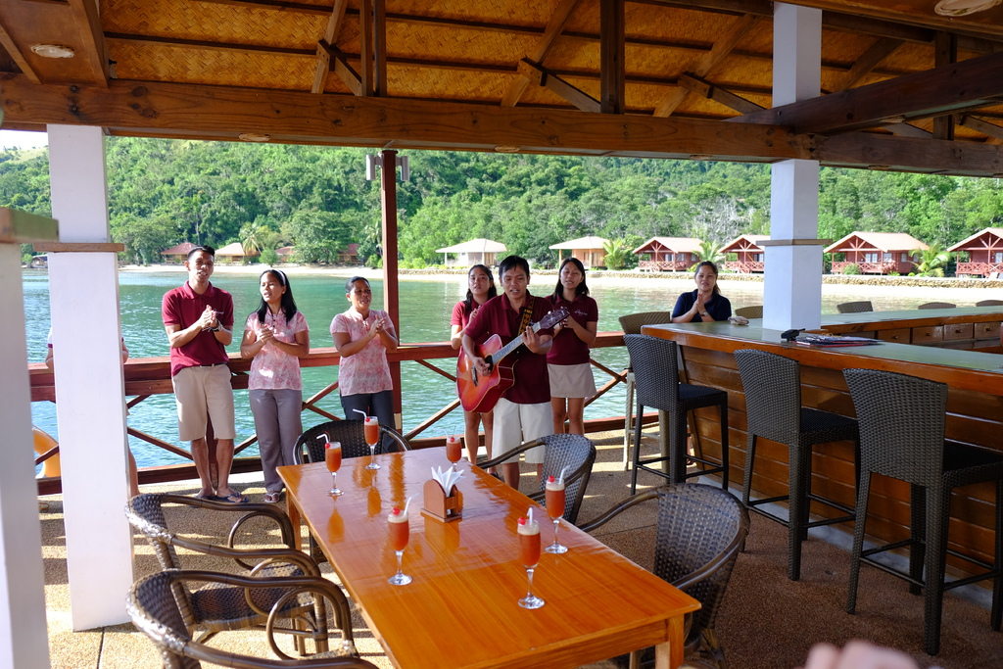

Fig. 49: Staffs welcome performance.

Source: Retrieved May 1, 2016, from https://styleme.pixnet.net/post/191897704



Fig. 50:Welcome Drink. Mango Shake.

Source: : Retrieved May 1, 2016, from [www.recipeshubs.com](http://www.recipeshubs.com/mango-shake/38995)

Normally, receptions are found in the main building of a resort. Here, Saya resort & spa wishes to create a refreshing atmosphere for the guests, so when the guests see the reception, they can immediately appreciate the uniqueness of the resort, that shouts out relaxation from the get go. At this stage, the receptionists help guests to check-in. After check-in, the receptionist will offer guests the local specialty: Banana chips, the dessert that every tourists must taste during the trip. Through this process, resort administrators believe that they can create a totally warm and relaxed atmosphere for the guests. Making them feel as if their stay as already started, creating the perfect first impression

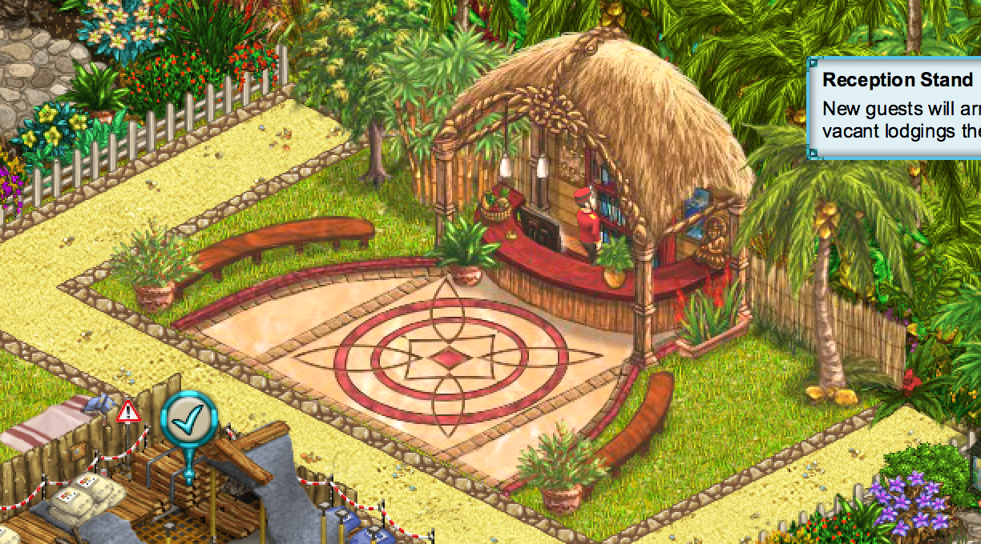

Fig. 51: Characteristic Reception Design

Source: (GmbH, no date)

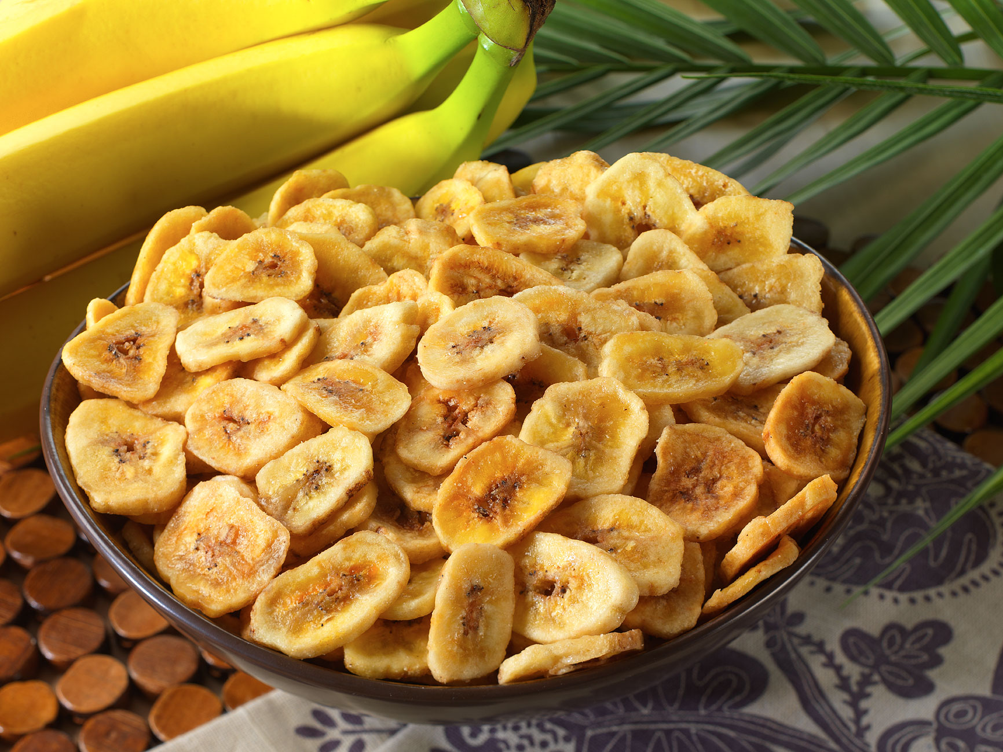

Fig. 52: Banana Chips

Source: Chips de banane, 1996

After guests settle down, the guest relationship officers will invite them to have a small tour in the resort by golf cart. It’s not only a good opportunity to show all the facilities and views in the resort, but also a chance to enhance the hotel impression to guests. Through all the details mentioned in 4.2 and 4.3, the atmosphere is built as the administrators expect.

* 1. Customer interaction with the service delivery system

According to Admin (2016) a successful service delivery system includes four key elements: service culture, service quality, employee engagement and customer experience. Saya Resort and Spa considers all of these elements and applies them to the joining stage, consumption phase and detachment phase.

* + 1. Consumption phase

In consumption phase, resorts provide a variety service in different facilities with well trained staff, here are some special service offered by resorts:

**Restaurant:**

Saya Resort and Spa has two restaurants: Masaya Restaurant and Lakas Restaurant. For best service and entertainment, the kitchens are designed as “open kitchen restaurant” where chefs cook in front of customers.

**Room Massage:**

You can make a reservation with the front desk for a room massage at a time that suits you, the resort offers a free 1 hour massage per person per night. The well trained masseur will do you a massage in the comfort of your own room. It is the best way to relieve fatigue after a day out doing water activities.



Fig. 53: Room service massage

source: Retrieved May 1, 2016, from http://www.massagewaikoloa.com/

* 1. Benefits

The following table presents the benefits for our customers:

Table 10: Benefits







1. Strategic direction

To elaborate on the unique selling point as well as highlight the benefits for our customers the authors created an overview with the features and benefits (see Appendix F)

* 1. Vision statement

In touch with nature, preserving its beauty in a sustainable way, equality and nurture are the key to growth and financially stability.

* 1. Positioning statement

Ultimate relaxation and sport experience in a breath-taking secluded location. Saya Resort and Spa offers sport and nature fans a variety of leisure activities. Travelers wanting to unwind profit from private forest rooms and natural based spa treatments.

This will satisfy our stakeholders – such as employees will feel taken care of, also customers who want to travel eco-friendly and want to protect the environment, as well as environment protection agencies and also the government because we will create jobs. So it will be an approach which addresses different stakeholders' needs.

By applying Porter’s Generic strategies the positioning is explained:

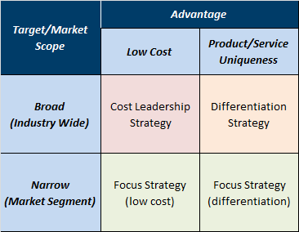

Fig. 54: Porter’s Generic strategies.

Source: Ahmed, 2014.

The resort will follow a focus strategy (differentiation) by concentrating on a narrow market segment. The aim is not to target the masses but to stay in line with the eco-theme of Palawan and target a specific market segment.

* 1. Target market

The following chapter describes the target market. Table 11 gives an overview over different generations since it will be referred to it.

Table 11: Overview over the different generations.

Source: Times Newspapers Limited, 2013

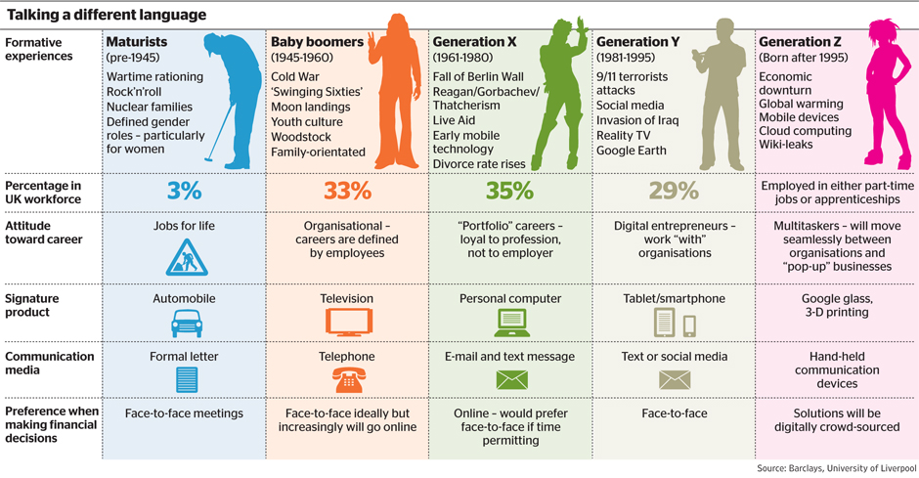

Travelers wanting to discover untouched and secluded places

Our target group are travelers coming from different corners of the world (according to the market research typically from Korea, USA, Japan) who are not travelling with children because the travel might be too exhausting for families (transportation is not considered to be very convenient, see market research) and we want to keep a quiet atmosphere in our resort.

They typically come from generation Y (see interview with Chinese travel agencies). They want to experience something unique and want to avoid mass tourism. At the same time they seek a special experience when it comes to the location as well. The region of Palawan responds to these need of a special place. The resort will also offer them an unique experience matching to the unique environment.

Sport and nature fans wanting a touch of luxury while looking for adventure

We are targeting sport fans and students (see market research a lot of students in the Philippines and other Koreans travelling interested in leisure, Spa and activities) who are seeking the best of both worlds, sport and a touch of luxury, whilst taking care of the environment. They are not the typical backpackers looking for a cheap deal. There are already 81.3 % of the accommodations offering a low level service in Northern Palawan. So we do not need to compete in this segment.

Our idea is that they also do not want to be in a high end luxury resort and so they will find the perfect mix at our hotel. Like the Market research showed there is room for expansion for mid -tier accommodation facilities. During the day they can choose from a variety of sport activities and in the evening they can recharge their energy.

Sing, Dash & Vashko (2016) came up with a model classifying tourists seeking ecotourism as well as sport tourism.

Ecotourism

Low High

Sport Tourism

Low High

lldad

Fig. 55: Framework for Sport- Eco-tourists.

Source: Sing, Dash & Vashko, 2016.

Explanation of the different types of travelers see Appendix G.

According to this framework the resort will target the Green tourists as well as action-oriented tourists. Green tourists will like the vision of the resort and active tourists will have a wide range from activities to choose from.

For groups travelling together our Baybayin villa will be ideal. Share a villa together and enjoy friendship.

Travelers wanting to unwind

Our target group are also people who just want to unwind and escape from the pressure of work or being constantly online. They want a tranquil holiday, away from crowded places. This respond to the global trends (see market research) and this need was also confirmed by Tourasia a Swiss travel agency specialized on the Asian travel market.

The location of the resort is ideal for people who want to unwind. By targeting this segment, the potentially negative aspect of not having a strong wifi connection or having a long trip till they reach the resort, can be turned into an advantage as it allows people to break away from their daily distractions and duties.

At this stage of the conception phase it is hard to tell which generation will mostly be attracted by this offering. The gathered data from Chinese travel agencies indicate that mostly the generation Y travels to Palawan, El Nido.

But this could also attract generation X.

Our gubat rooms (forest rooms) offering privacy will be ideal for this segment.

Local people wanting to profit from our Spa facilities

In the market research we saw that Filipinos (domestic market) make up a significant part of the tourists coming to Palawan. Therefore, the spa facilities will be open to the public.

SWOT analysis

To summarize the concept a SWOT analysis is presented:



Fig. 56: SWOT Analysis.

Bibliography

11°18’00.0"N 119°25’00.0"E (no date) Available at: https://www.google.ch/maps/place/11%C2%B018'00.0%22N+119%C2%B025'00.0%22E/@11.2813043,119.3182483,11.81z/data=!4m5!3m4!1s0x0:0x0!8m2!3d11.3!4d119.4166667?hl=en (Accessed: 4 May 2016).

Resorts, E.N. (2016) El Nido resorts. Available at: http://www.elnidoresorts.com/ (Accessed: 4 May 2016).

Admin (2015) Four Key Elements of a Service Delivery System, Available at: http://servicefutures.com/service-management/four-key-elements-service-delivery-system/(Accessed: 1 May 2016).

Ahmed, G. (2014) Michael Porter’s generic strategies. Available at: http://www.studylecturenotes.com/management/michael-porters-generic-strategies (Accessed: 30 April 2016).

Asia Times (2015) *Seoul to dispatch police to Philippines over murder of Korean*. Available at: http://atimes.com/2015/12/seoul-to-dispatch-police-to-philippines-over-murder-of-korean/ (Accessed: 2 May 2016).

CIA (2016a) The world Factbook. Available at: https://www.cia.gov/library/publications/the-world-factbook/geos/ks.html (Accessed: 28 April 2016).

CIA (2016b) *The world Factbook*. Available at: https://www.cia.gov/library/publications/the-world-factbook/geos/rp.html (Accessed: 17 April 2016).

Conde Nast Traveler (2016) *11 photos of the most beautiful island in the world*. Available at: http://www.cntraveler.com/galleries/2015-07-13/visiting-the-most-beautiful-island-in-the-world-palawan-philippines (Accessed: 23 April 2016).

Department of Tourism (2016) *INDUSTRY PERFORMANCE FOR TRAVEL AND TOURISM*. Available at: http://www.tourism.gov.ph/Pages/IndustryPerformance.aspx (Accessed: 21 April 2016).

Department of Tourism Philippines (2009) *Product development*. Available at: http://www.tourism.gov.ph/Pages/ProductDevelopment.aspx (Accessed: 28 April 2016).

*菲律宾英语学院对比一览表* (no date) Available at: http://www.52leyu.com/philippines/contrast/ (Accessed: 5 May 2016).

Dua Ransel (2013) *El Nido Mini guide*. Available at: http://www.duaransel.com/asia/filipina/el-nido-mini-guide/ (Accessed: 2 May 2016).

Elegance Paradise (2014) *Cinema on the beach at Constance Moofushi*. Available at: http://www.elegancesholidays.com/english/blog/cinema-on-the-beach-at-constance-moofushi- (Accessed: 30 April 2016).

Fuggle, L. (2016) *6 travel trends for 2016 that will drive the global tourism industry*. Available at: https://www.trekksoft.com/en/blog/travel-industry-trends-2016 (Accessed: 23 April 2016).

Geiger, Michèle EDA GEI (2015) *Leben und Arbeiten auf den Philippinen*. Available at: https://www.eda.admin.ch/content/dam/eda/de/documents/publications/AuslandschweizerinnenundAuslandschweizer/dossier-auswandern/leben-und-arbeiten-philippinen_DE.pdf (Accessed: 30 April 2016).

Interaksyon (2015) *How does Palawan plan to reach its target of 1.4 million tourists in 2015?* Available at: http://interaksyon.com/business/108008/how-does-palawan-plan-to-reach-its-target-of-1-4-million-tourists-in-2015 (Accessed: 23 April 2016).

Lim, N.Z. (2015) *Asia Pacific Projects Research & statistics*. Available at: http://www.asiapacificprojects.com/research-and-statistics/research-and-statistics/Investing-in-Tourism-in-Palawan/ (Accessed: 28 April 2016).

Official Gazette of the Republic of the Philippines (2016) *Uninterrupted, robust tourism growth since 2010*. Available at: http://www.gov.ph/2016/03/03/tourism-growth-aquino-admin/ (Accessed: 21 April 2016).

Palawan Government (no date) Official Website - provincial government of Palawan. Available at: http://palawan.gov.ph/demography.html (Accessed: 28 April 2016).

Philippine Retirement Authority (2007) *Why retire in the Philippines*. Available at: http://www.pra.gov.ph/main/why_retire?page=1 (Accessed: 28 April 2016).

Picture it’s more fun in the Phillipines (no date) Available at: http://www.itsmorefuninthephilippines.com (Accessed 14 April 2016).

Satyendra Singh, Tapas R. Dash & Irina Vashko , (2016),"Tourism, ecotourism and sport tourism: the framework for certification", Marketing Intelligence & Planning, Vol. 34 Iss 2 pp. 236 - 255 Permanent link to this document:  
http://dx.doi.org/10.1108/MIP-09-2014-0180 (Accessed: 23 April 2016).

The Department of Tourism Manila Philippines (2009) *History*. Available at: http://www.tourism.gov.ph/SitePages/History.aspx (Accessed: 17 April 2016).

The Economist (2016) *The big Mac index*. Available at: http://www.economist.com/content/big-mac-index (Accessed: 28 April 2016).

Times Newspapers Limited (2013) *Baby boomers ‘hold the advantage’ as generation X suffers a mid-life crisis.* Available at: http://www.thetimes.co.uk/tto/business/economics/article3863837.ece (Accessed: 30 April 2016).

Trade Section Embassy of Switzerland, S.G.E. (2014) *PHILIPPINES AT A GLANCE*. Available at: http://www.s-ge.com/sites/default/files/private_files/1408_FS_Philippines.pdf (Accessed: 30 April 2016).

Around the World in KT Days. (2015). *The Ultimate Guide to an Active El Nido Vacation*. [online] Available at: http://aroundtheworldinktdays.com/the-ultimate-guide-to-an-active-el-nido-vacation/ [Accessed 2 May 2016].

Divers, P. (2015). *Activities in El Nido*. [online] Palawan Divers. Available at: http://www.palawan-divers.org/activities-in-el-nido/ [Accessed 1 May 2016].

Elgordoadventures.com. (2016). *El Gordo's Action Adventures*. [online] Available at: http://elgordoadventures.com/expeditions.html [Accessed 1 May 2016].

Fourseasons.com. (2016). *Dive-In Movies at the Pool | Four Seasons Resort Orlando*. [online] Available at: http://www.fourseasons.com/orlando/services_and_amenities/recreation/dive_in_movies/# [Accessed 1 May 2016].

From 1 to 10. (2016). *10 Tips For Your El Nido Trip (Part II) • From 1 to 10*. [online] Available at: http://from1to10.com/2016/01/10-tips-for-your-el-nido-trip-part-ii/ [Accessed 2 May 2016].

Google.ch. (2016). *11°18'00.1"N 119°25'04.2"E*. [online] Available at: https://www.google.ch/maps/dir/11.1803959,119.3891914/11.3000278,119.4178333/@11.2303204,119.3998917,13z/data=!4m2!4m1!3e0 [Accessed 2 May 2016].

Gopalawan.travel. (2016). *Palawan Hotels & Tours - Book Online at discounted rates with gopalawan.travel*. [online] Available at: http://www.gopalawan.travel/ [Accessed 1 May 2016].

Gopalawan.travel. (2016). *Tours in El Nido Palawan*. [online] Available at: http://www.gopalawan.travel/palawan-tours/el_nido [Accessed 2 May 2016].

Guidetoboracay.com. (2016). *Guide To Boracay » Beaches and Activites*. [online] Available at: https://guidetoboracay.com/beaches-and-activites/ [Accessed 1 May 2016].

Philippines–South Korea relations (2016) in Wikipedia. Available at: https://en.wikipedia.org/wiki/Philippines%E2%80%93South_Korea_relations (Accessed: 5 May 2016).

Halfmoon.rockresorts.com. (2016). *Jamaica Horseback Riding | Equestrian Centre at Half Moon Resort*. [online] Available at: http://halfmoon.rockresorts.com/discover/equestrian-centre-en.html [Accessed 1 May 2016].

itsmorefuninthephilippines.com. (2016). *Puerto Princesa*. [online] Available at: http://itsmorefuninthephilippines.com/puerto-princesa/ [Accessed 1 May 2016].

Lfsmexpo.com. (2016). *» 546658-beach-volleyball*. [online] Available at: http://lfsmexpo.com/546658-beach-volleyball/ [Accessed 1 May 2016].

News, A. (2012). *'Bourne' ends shoot in El Nido, Palawan*. [online] News.abs-cbn.com. Available at: http://news.abs-cbn.com/entertainment/02/02/12/bourne-ends-shoot-el-nido-palawan [Accessed 1 May 2016].

Palawan Divers. (2016). *How to get to El Nido? - Palawan Divers*. [online] Available at: http://www.palawan-divers.org/how-to-get-to-el-nido/ [Accessed 1 May 2016].

Palawan Sailing - El Nido. (2014). *Your IYT sailing school in El Nido - Palawan Sailing - El Nido*. [online] Available at: http://www.palawan-sailing.com/ [Accessed 2 May 2016].

Palawanselfdrivecarrental.com. (2016). *Palawan Self Drive Car Rental*. [online] Available at: http://www.palawanselfdrivecarrental.com/rates.html [Accessed 1 May 2016].

Pinterest. (2016). *Beach BBQ*. [online] Available at: https://uk.pinterest.com/pin/301107925056605310/ [Accessed 1 May 2016].

Pool and Hot Tub Blog. (2016). *mckimmd123*. [online] Available at: https://gibsan.wordpress.com/author/mckimmd123/ [Accessed 1 May 2016].

Seller, C. (2016). *Get your PADI in El Nido - Diving*. [online] Padi.com. Available at: http://www.padi.com/blog/2015/05/14/get-your-padi-in-el-nido/ [Accessed 2 May 2016].

Studlandstables.com. (2016). *Studland Riding Stables Prices*. [online] Available at: http://www.studlandstables.com/prices.htm [Accessed 1 May 2016].

System, S. (2016). *Internet Booking Air Swift - Search Flight*. [online] Awan.sqiva.com. Available at: http://awan.sqiva.com/app-ibe-airswift-search_flight?dep_date=20160518&ret_date=20160525&class=Y&return_flight=1&org=MNL&des=ENI&dep_date_mmddyy=05%2F18%2F2016&ret_date_mmddyy=05%2F25%2F2016&pax_adult=1&pax_child=0&pax_infant=0 [Accessed 1 May 2016].

Travel Therapy Tours. (2016). *BEACH YOGA IN LISBON - Travel Therapy Tours*. [online] Available at: http://traveltherapytours.com/holiday/beach-yoga-in-lisbon/ [Accessed 1 May 2016].

Tripadvisor.com. (2016). *Nacpan Beach (El Nido, Philippines): Address, Attraction Reviews - TripAdvisor*. [online] Available at: https://www.tripadvisor.com/Attraction_Review-g294256-d4227525-Reviews-Nacpan_Beach-El_Nido_Palawan_Island_Palawan_Province_Mimaropa.html [Accessed 2 May 2016].

Tripadvisor.com. (2016). *The 10 Best El Nido Restaurants 2016 - TripAdvisor*. [online] Available at: https://www.tripadvisor.com/Restaurants-g294256 El_Nido_Palawan_Island_Palawan_Province_Mimaropa.html [Accessed 1 May 2016].

Vito, J. (2015). *33 THINGS TO DO IN EL NIDO, PALAWAN*. [online] Top On My List. Available at: http://www.toponmylist.com/33-things-to-do-at-el-nido-palawan/#sthash.3ZwZGWFn.VmP1kjLk.dpbs [Accessed 1 May 2016].

Wells, A. (2016). *Bowling Paradise Pro Beach - AndroidTapp*. [online] AndroidTapp. Available at: http://www.androidtapp.com/bowling-paradise-pro/bowling-paradise-pro-beach/ [Accessed 1 May 2016].

irisakimura. (2016). El Rio Y mar resort. Retrieved May 4, 2016, from <https://styleme.pixnet.net/post/191897704>

Mango shake. (2016). Retrieved May 4, 2016, from <http://www.recipeshubs.com/mango-shake/38995>

GmbH, upjers. Manager games - play free now! Retrieved May 4, 2016, from <https://mysunnyresort.upjers.com/en/>

*, N. (2016). 60 serving banana chips bucket. Retrieved May 4, 2016, from <http://ourfamilysurvivalcenter.com/shop/60-serving-banana-chips-bucket/>

Phiresort. Retrieved May 4, 2016, from http://royalcrystal4040.wix.com/phiresort

Brown, A. (2014). We come to you - relax and Destress! Retrieved May 4, 2016, from <http://www.massagewaikoloa.com/>

Inc, P. M. (2015, May 10). El Nido, Palawan: That beach at the last frontier. Retrieved May 4, 2016, from http://primer.com.ph/travel/2015/05/10/el-nido-palawan-that-beach-at-the-last-frontier/

Appendix A

A statement of Tourism Secretary Ramon R. Jimenez, Jr. (cited in Official Gazette of the Republic of the Philippines 2016) summarizes the development in the last years:



The DOT, names the following **factors** which could have contributed to the **considerable growth in 2015**:

* Aggressive branding and promotional activities
* Visit the Phillippines Year (VPY) 2015
* Destination-based marketing materials
* Introduction of new and exciting destinations/products
  + National Parks
  + Nature and Ecotourism Sites
  + Scuba Diving
  + Festivals and Events
  + Beach Resorts
  + Golf Courses (Department of Tourism Philippines, 2009)
* Influx of visitors during Christmas holidays
* Hosting major international events such as visit of Pope Francis, Iron Man challenge or Madrid Fusion Manila (Official Gazette of the Republic of the Philippines 2016)

Appendix B

**E-Mail from tourasia 29 April 2016**

Grüezi Frau von Niederhäusern

Herzlichen Dank für Ihr E-Mail. Gerne beantworte ich Ihre Fragen:

***Wie beliebt sind die Philippinen als Reisedestination? Was hält Leute davon ab zu buchen?***Die Philippinen liegen bei uns im asiatischen Raum im hinteren Bereich. Hauptgründe dafür sind wohl die lange Anreise (keine Direktflüge) sowie die meist negativen Berichterstattungen in den Medien (Naturkatastrophen, Armut). Im asiatischen Vergleich sind Hotelpreise zudem meist höher als zum Beispiel in Thailand, da das Hotelangebot beschränkt ist und man für die Exklusivität bezahlt.

***Was raten Sie bezüglich der Sicherheitslage?***

Die Philippinen bestehen aus 7107 Inseln und der grösste Teil der Philippinen ist absolut sicher und kann problemlos bereist werden. Wir beziehen uns auf die vom EDA aktuell publizierten Reisehinweise und bieten problematische Regionen wie die Sulu-See oder Mindoro nicht an (siehe: <https://www.eda.admin.ch/eda/de/home/vertretungen-und-reisehinweise/philippinen/reisehinweise-fuerdiephilippinen.html>)

***Was muss ein Resort tun, um in Ihren Katalog aufgenommen zu werden?***

Alle im tourasia-Katalog veröffentlichten Hotels sind von uns persönlich geprüft. Als tourCert-Mitglied müssen unsere Hotelpartner im gemeinsamen Vertrag unterschreiben, dass sie nach dem Code of Conduct ([www.thecode.org](http://www.thecode.org/)) handeln, welcher Themen wie faire Arbeitsbedingungen, Umweltschutz und Schutz vor Kinderausbeutung beinhaltet.

***Ist das primäre Ziel der Kunden, die die Philippinen wählen Sporttourismus, Wellness, Tauchausflüge, Flitterwochen? Warum die Philippinen und nicht Thailand oder eine andere Destination.***

Die Philippinen haben traumhafte Strände, eine unglaublich vielseitige Unterwasserwelt und die lokale Bevölkerung ist sehr freundlich, aufgestellt und spricht zudem sehr gut Englisch. Das heisst man kommt viel schneller mit der lokalen Bevölkerung in Kontakt als in anderen asiatischen Ländern und kann sich sehr gut verständigen. Grundsätzlich kann man sagen, dass die Inselwelt so einmalig ist wie ihre Gäste, Touristenmassen gibt es kaum. Philippinenferien sind Ferien für Individualisten, weg von der Masse. Dabei gilt es, aus Tausenden von Inseln das richtige Angebot für jeden Gast individuell zusammen zu stellen.

***Wir fokussieren uns auch insbesondere auf Palawan. Warum gehen die Touristen dahin?***

Palawan ist Natur pur, noch kaum bereist. Hier kann der Gast seinen persönlichen Inseltraum verwirklichen. Zudem hat es die Region geschafft, den faszinierenden natürlichen Lebensraum inkl. seiner Artenvielfalt über Jahre hinweg zu erhalten indem einige Regionen zu Naturschutzgebieten erklärt wurden. El Nido und Coron im Norden gehören zu den schönsten und attraktivsten Gegenden auf den Philippinen. Schneeweisse, puderfeine Sandstrände, spektakuläre Kalksteinfelsen und eine unglaublich schöne und intakte Unterwasserwelt sind hier zu finden.

***Sind es 5* Resorts oder eher Mittelklasse Resorts, die gefragt sind?***

Die meisten unserer Hotels auf Palawan sind im oberen Preissegment (lokale 5* Häuser). Diese Häuser legen sehr viel Wert auf Umweltschutz und bieten die Lage und den Service welche unsere Kunden erwarten.

***Was würden Sie allgemein sagen, was wünscht sich die Kundschaft? Ruhe, spezielle Angebote....?***

Die Gäste welche Palawan besuchen, suchen in erster Linie Ruhe, eine wunderschöne Natur, sowie eine intakte Unterwasserwelt. Viele Regionen auf Palawan wurden zu Naturschutzgebieten erklärt, somit findet man auf Palawan keine „Bausünden“, sondern Natur pur, abseits der Touristenmassen (Touristenmassen und „Bausünden“ findet man vor allem auf Boracay oder Cebu).

Für weitere Fragen stehe ich Ihnen gerne zur Verfügung.

Freundliche Grüsse und ein schönes Wochenende

**Christa Buehlmann** ¦ Product Manager

tourasia ¦ Grindelstrasse 5 ¦ CH-8304 Wallisellen ¦ Switzerland

Phone: +41 43 233 30 94 ¦ Fax: +41 (0)43 233 30 79

e-mail: [christa.buehlmann@tourasia.ch](mailto:christa.buehlmann@tourasia.ch)

Internet: [www.tourasia.ch](http://www.tourasia.ch/)

**„Reiseideen von Asienexperten unter** [**www.tourasia.ch**](http://www.tourasia.ch/)**“**

Appendix C



Key data about Palawan, no date specified. 

source: Palawan Government (no date).

Appendix D



source: Department of Tourism, 2016, Official Gazette of the Republic of the Philippines, 2016.

Appendix E

Indigo perlas offers different bays using the natural medicinal materials in the surrounding natural environment, as well as flowers, grass, etc to balance the mind.

As slowing down and finding inner balance leads to a release of power. From our natural aromatherapy to innovative and lasting anti-aging treatments, everything can be adapted to suit customers’ own personal needs.

We also provide beauty facial treatments, variety of massage therapies including Chinese style of acupuncture, cupping and scraping treatments as well as body treatments and special treatments for couples.

The Body treatment would be one of the star courses of treatment within our resort which focuses on cleansing and detox ,including the Thalasso body treatment with anti-cellulite effect. This holistic body treatment based on highly active marine ingredients provides a noticeable remodeled body contour and sensational well-being. Effective, precious algae extracts in the exfoliant, body pack and massage oil have an intensive detoxifying and cleansing effect. The result – visibly and palpably refined, strengthened skin, relaxation, just like after a short break by the sea.

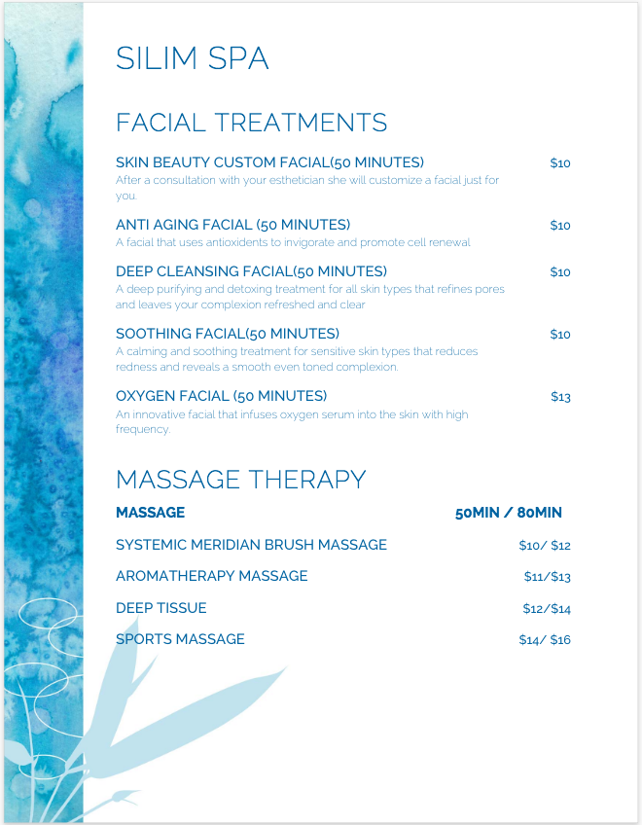

Appendix F

Tables of Benefit

Appendix G



Source: Sing, Dash & Vashko, 2016

1. There is a 750m zipline joining Las Cabanas to Snake Island. Php500 one way, PHP400 more to come back, otherwise you can walk at low tide or swim.
2. International Yacht Training Worldwide